Student Performance Prediction System

Project Id: AIML-5

Name : Member1 (Kulvardhan Singh Khichi)
Class Roll Number:80
University Roll Number : 2028448
Section and Group: G and G2

Name : Member2- Shivank Mahajan
Class Roll Number:62
University Roll Number : 2028848
Section and Group: G and G2

- Problem Description 3
- Architecture 4
- Models model 5
- Evaluation metrics used 6
- Preliminary Results and Visualizations 7
- References 8

- Problem Description

Design and develop an end-to-end machine learning classification system to predict
loan default using customer banking data. The project should begin with exploratory
data analysis (EDA) to understand data distributions, correlations, and patterns,
followed by comprehensive data preprocessing including data cleaning, normalization,
transformation, and dimensionality reduction using Principal Component Analysis
(PCA) to handle high-dimensional data. The system should implement Support Vector
Machine (SVM) classifiers using different kernel functions such as linear, polynomial,
and radial basis function (RBF) and K-NN. The trained models must be evaluated and
compared using standard classification performance metrics including precision, recall,
F1-score, and ROC–AUC. The project should demonstrate a complete machine learning
pipeline from raw data analysis to model evaluation, emphasizing best practices in
preprocessing, model selection, and performance assessment.

- Architecture
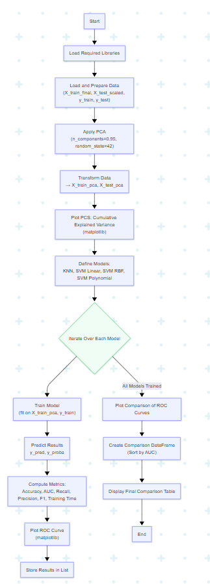

Fig.1 Sample flow diagram.

- Models Used(Applied/ Planned) Give a brief introduction of the models used

The following machine learning classification models were implemented and trained on the PCA-reduced training dataset:
- K-Nearest Neighbors (K-NN): Configured with 5 nearest neighbors (k=5) to classify data points based on proximity in the reduced feature space.
- Support Vector Machine (SVM) - Linear Kernel: Applied to find a linear decision boundary separating the classes.
- Support Vector Machine (SVM) - RBF Kernel: Applied to handle non-linear relationships using a radial basis function mapping.
- Support Vector Machine (SVM) - Polynomial Kernel: Configured with a 3rd-degree polynomial to capture complex feature interactions.

- Evaluation metrics used

Evaluation Metrics Used
The models were evaluated using the following standard classification metrics:
- Accuracy: To measure the overall proportion of correct predictions.
- Precision: To measure the accuracy of the positive predictions (defaulters).
- Recall: To measure the ability to find all actual positive instances (defaulters).
- F1-Score: The harmonic mean of precision and recall.
- ROC-AUC Score: To evaluate the model's ability to distinguish between the two classes across different threshold levels.

5. Preliminary Results and Visualizations
Dimensionality Reduction: The dataset initially contained 23 features. Applying Principal Component Analysis (PCA) to capture 95% of the cumulative explained variance successfully reduced the feature count down to 15 principal components, optimizing the dataset for SVM and KNN training.

Visualizations:
The code generates two primary visualizations representing these results:
- PCA Cumulative Explained Variance Line Plot: Demonstrating the variance captured across the components and highlighting the 95% threshold cut-off.
- ROC Curve Plot: Plotting the True Positive Rate against the False Positive Rate for K-NN, Linear SVM, RBF SVM, and Polynomial SVM, alongside their respective AUC scores to provide a direct visual comparison of model performance.

5. Preliminary Results and Visualizations

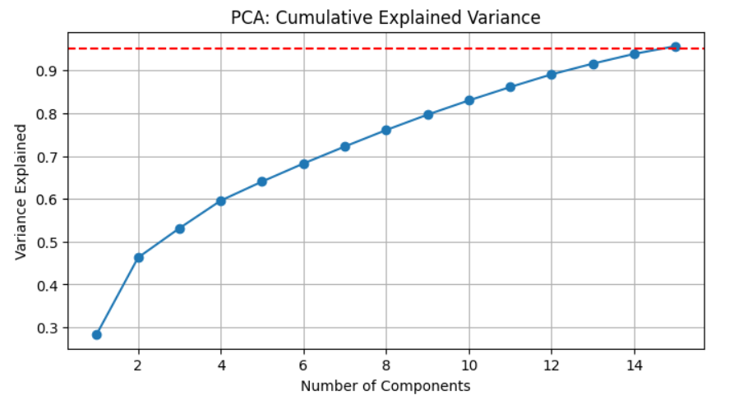

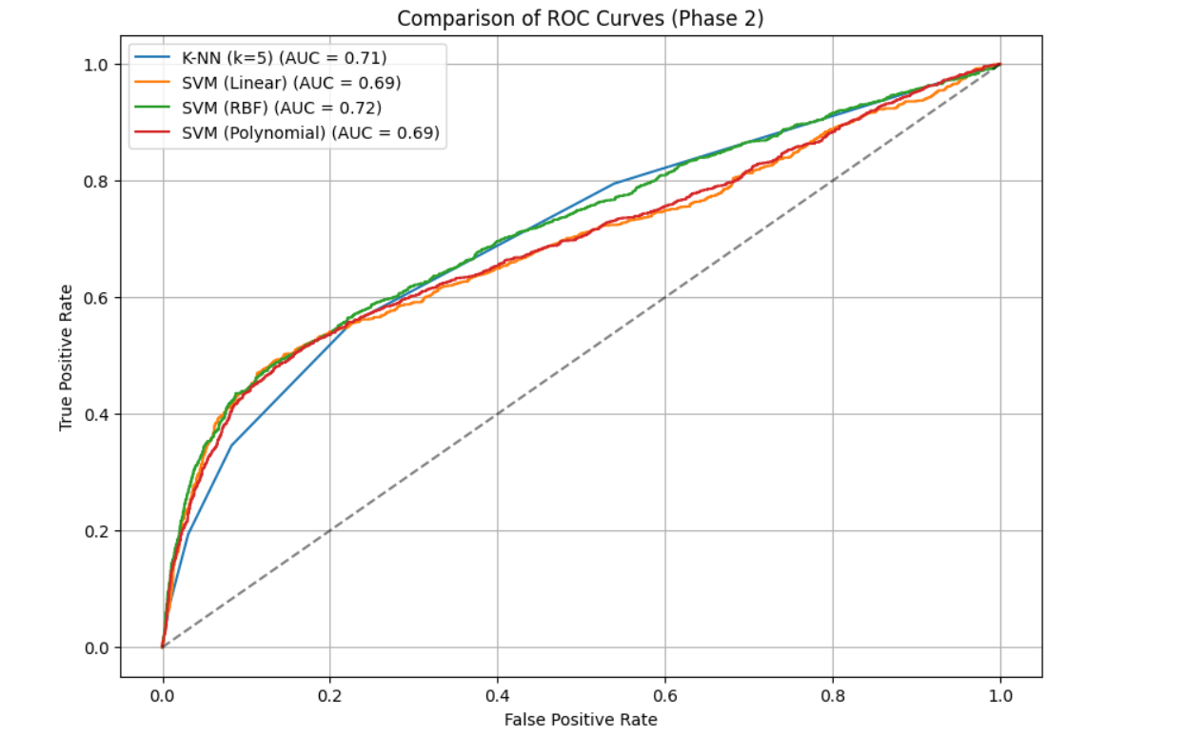

6. References:
Books:
- Let Us Python – Yashavant Kanetkar

Online Resources:
  - GeeksforGeeks – https://www.geeksforgeeks.org/
  - TutorialsPoint – https://www.tutorialspoint.com/cprogramming/index.htm
  - Stack Overflow – https://stackoverflow.com
  - Leet code - https://leetcode.com/

